Enhancing Accessibility and Personalization in E-learning for Dyslexia Learners

R26-SE-031

Project Proposal Report
Ekanayake E.M.I.S – IT22154880

B.Sc. (Hons) Degree in Information Technology Specialized in
Software Engineering

Department of Information Technology

Sri Lanka Institute of Information Technology Sri Lanka

March 2025

DECLARATION
I declare that this is my own work, and this proposal does not knowingly incorporate any material previously submitted for a degree or diploma at any other university or higher education institution, nor does it contain any material that has been previously published or written by another person apart from where proper acknowledgment is given in the text
Name | Student ID | Signature
Ekanayake E.M.I.S | IT22154880 | 

The above candidate is conducting research for their undergraduate Dissertation under my supervision.

Name | Date | Signature
Ms. Thilini Jayalath

ABSTRACT
Dyslexia is a common learning difficulty that affects reading accuracy, fluency, and comprehension among primary school students. Many children with dyslexia struggle with traditional classroom teaching because learning materials and instructional strategies are not adapted to their reading needs. In Sri Lanka, early identification and learning support for students with dyslexia remain limited due to the lack of accessible digital learning tools.
Existing digital learning platforms often provide static learning materials and do not adapt to learning environments according to learner behavior. Research indicates that adaptive learning technologies can dynamically adjust learning environments and educational content according to learner characteristics and learning progress [1]. Similarly, AI-based assistive technologies can provide personalized learning support for students with dyslexia by analyzing learner behavior and adapting instructional strategies [2]. However, many systems do not integrate learner behavior monitoring, adaptive visual interfaces, and personalized learning content within a single platform.
To address this gap, this research proposes an adaptive mobile learning system to assist primary school students with dyslexia. The system analyzes learner interaction data during reading activities to detect reading difficulties and personalize the learning experience. The architecture integrates a cognitive learning signal monitoring mechanism, an adaptive visual learning interface that improves readability through typographic adjustments, a personalized learning content engine that selects literacy exercises based on learner performance, and an intelligent learning guidance mechanism that recommends supportive instructional strategies.
The system will be implemented as a mobile learning application using mobile development frameworks, machine learning techniques, and cloud-based technologies. The expected outcome is a personalized learning platform that improves reading engagement and supports literacy development for students with dyslexia while providing social benefits as an educational technology solution.
Keywords: Dyslexia, Adaptive Learning System, Personalized Learning, Educational Technology, Mobile Learning

ACKNOWLEDGEMENT
I would like to express our sincere gratitude to our research supervisor, Ms. Thilini Jayalath, for her continuous guidance, encouragement, and valuable insights throughout the development of this research proposal. Her expertise, constructive feedback, and support greatly contributed to shaping the direction and quality of this research work.
I also extend our heartfelt appreciation to our external supervisors, Ms. D. M. Dasunika Isurindi Dissanayake, Speech and Language Therapist and Visiting Lecturer at the Faculty of Medicine, University of Kelaniya, and Ms. Dinusha Fonseka, Speech and Language Therapist and Visiting Lecturer at the Faculty of Medicine, University of Kelaniya. Their professional knowledge and valuable advice regarding dyslexia and learning difficulties provided essential guidance for understanding the practical aspects of this research.
I would like to sincerely thank Ayati Trust Sri Lanka and the Ayati Centre, Faculty of Medicine, University of Kelaniya, for their support and for providing valuable opportunities to understand the challenges faced by children with dyslexia. The interaction with professionals and students associated with the center provided important insights that supported the development of this research project.
I am also grateful to Sri Lanka Institute of Information Technology (SLIIT) for providing the academic environment, resources, and technological support necessary to carry out this research work.
Finally, I would like to thank all individuals and organizations who supported us directly or indirectly in the successful preparation of this research proposal.

Table of Contents
2 INTRODUCTION 9
2.1 Background and Context 9
2.2 Literature Review 11
2.3 Research Gap 13
3 OBJECTIVES 15
3.1 Main Objective 15
3.2 Specific Objectives 16
4 METHODOLOGY 17
4.1 Research Approach 17
4.2 Technical Methods and Algorithms 17
4.3 Tools and Platforms 18
4.4 Data Collection and Ethical Considerations 18
4.5 Validation Strategy and Performance Metrics 19
5 HIGH-LEVEL SYSTEM ARCHITECTURE 20
5.1 Highlight the Individual Component and Its Parts 22
5.2 Component Interactions 22
5.3 Data Flow Explanation 23
5.4 Scalability and Security Considerations 24
6 USER REQUIREMENTS 25
6.1 Stakeholder Identification 25
6.2 Functional Requirements 25
6.3 Non-Functional Requirements 26
7 COMMERCIALIZATION PLAN 27
7.1 Target Market and Customer Persona 27
7.2 Value Proposition 27
7.3 Revenue Model 27
7.4 Cost Estimation 28
7.5 Pricing Strategy 28
7.6 Competitive Advantage 29
7.7 Intellectual Property Considerations 29
8 BUDGET AND JUSTIFICATION 30
9 WORK BREAKDOWN STRUCTURE(WBS) 32
10 GANTT CHART 33
11 REFERENCES LIST 34
12 APPENDICIES 35
12.1 Appendices A 35
12.2 Appendices B 35

LIST OF TABLES
Table 1- summarize research gap 6
Table 2 - Pricing Strategy 18
Table 3 - Budget and justification 21
Table 4 - Risk Analysis 25

LIST OF FIGURES

Figure 1 - High Level System Architecture 11
Figure 2 - Data Flow Explanation 13
Figure 3 - Work breakdown structure 22
Figure 4- Gantt chart 23
Figure 5 - Component Interaction Diagram 25

LIST OF ABBREVIATIONS
Abbreviation | Full Meaning
AI | Artificial Intelligence
DSR | Design Science Research
SDG | Sustainable Development Goal
SDG 4 | Sustainable Development Goal 4 – Quality Education
UI | User Interface
UX | User Experience
FR | Functional Requirement
NFR | Non-Functional Requirement
WBS | Work Breakdown Structure
API | Application Programming Interface
ML | Machine Learning
DB | Database
LKR | Sri Lankan Rupees
TTS | Text-to-Speech
HCI | Human Computer Interaction
EDM | Educational Data Mining
LMS | Learning Management System

LIST OF APPENDICES
Appendices A - Risk Analysis ……………………………………………………… 35
Appendices B - Component Diagram ………………………………………………. 35

INTRODUCTION

Background and Context
Early literacy development is a fundamental component of primary education and plays a crucial role in shaping a child’s academic success. Reading ability acquired during early schooling significantly influences students’ future learning outcomes, comprehension skills, and participation in classroom activities. However, many children experience difficulties in acquiring reading and writing skills due to learning disorders such as dyslexia and other language-processing challenges. Dyslexia is widely recognized as a specific learning disorder that affects the development of reading accuracy, fluency, and spelling despite normal intelligence and educational opportunities [2] [3]. These difficulties often interfere with a child’s ability to decode written text, recognize words efficiently, and understand reading materials, ultimately affecting their academic performance and learning confidence.
Dyslexia is considered one of the most prevalent learning difficulties among school-age children. Research studies indicate that dyslexia affects a significant portion of the global population, with estimates suggesting that between 5% and 15% of learners experience some form of reading difficulty associated with dyslexia [2] [3]. This highlights the importance of providing effective learning support systems for students who struggle with reading-related tasks. Without early identification and appropriate educational interventions, children with dyslexia may continue to face long-term academic challenges, including slower learning progress, reduced classroom engagement, and limited educational opportunities [4]. These challenges emphasize the need for specialized learning approaches that support diverse learning abilities in early education.
Despite the growing awareness of learning difficulties, traditional educational systems typically rely on standardized teaching methods that are designed for the average learner. Such approaches often follow a fixed curriculum structure and provide the same instructional materials to all students. However, research has shown that traditional one-size-fits-all instructional methods are often ineffective for learners with dyslexia because they fail to address individual cognitive differences and learning style [5]. Dyslexic learners frequently require personalized learning strategies, structured literacy exercises, and multisensory teaching methods to effectively develop reading skills. Unfortunately, teachers in many educational environments may not have sufficient time or resources to provide individualized instruction for every student who experiences reading difficulties.
In recent years, digital learning platforms and educational technologies have emerged as potential tools to support teaching and learning processes. These systems offer interactive content, multimedia learning materials, and flexible learning environments that can enhance student engagement. However, many existing e-learning systems still follow a generic learning model where the same educational content is delivered to all learners regardless of their individual abilities or learning progress [1]. As a result, students with reading difficulties may still struggle to benefit from these platforms because the learning materials are not adapted to their specific needs. Additionally, several studies highlight that most assistive technologies for dyslexia focus primarily on accessibility features such as text-to-speech or spelling support rather than providing intelligent adaptive learning mechanisms that personalize content sequencing based on learner performance [6].
To address these limitations, researchers have increasingly explored adaptive learning technologies that can personalize educational experiences using artificial intelligence and learning analytics. Adaptive learning systems typically incorporate learner modeling, content management modules, and decision-making engines that dynamically adjust learning materials based on individual learner characteristics and performance data. According to recent studies, recommendation models and adaptive algorithms can significantly improve learning engagement and learning outcomes by tailoring educational content to the learner’s current knowledge state [7] [6]. These systems analyze student performance, learning behavior, and interaction patterns to recommend appropriate learning activities, thereby creating personalized learning pathways.
Although adaptive learning technologies have shown promising results, several challenges remain in applying these solutions to early literacy education. Many existing adaptive learning systems are primarily designed for higher education environments and may not adequately support young learners who require simpler learning interfaces and structured reading exercises [1]. Furthermore, some systems rely heavily on predefined rules or static learner profiles rather than continuously updating learner models based on real-time learning performance. In addition, current digital learning tools often lack integration between formal school curricula and specialized literacy exercises designed to support children with dyslexia.
To overcome these challenges, this research proposes the development of a Personalized Learning Content Engine designed to support early reading development among primary school students. The proposed component aims to dynamically recommend learning materials and literacy exercises based on each learner’s reading ability, progress, and learning behavior. By integrating learner modeling techniques, adaptive recommendation algorithms, and curriculum-aligned content repositories, the system can generate personalized learning pathways that help students improve reading skills while progressing through their academic curriculum. Such an approach ensures that learners receive appropriate educational content at the right difficulty level while maintaining motivation and engagement during the learning process.
The proposed Personalized Learning Content Engine functions as a key component within a broader intelligent learning support system designed to assist children with reading difficulties. The engine maintains a learner model that tracks student performance across multiple literacy-related sub-skills such as word recognition, phonological awareness, and reading comprehension. Using this information, the system selects suitable learning activities from a structured content repository that includes graded reading passages, phonetic exercises, and comprehension tasks. Adaptive recommendation algorithms are then applied to determine the next learning activity that best supports the learner’s current skill level and learning progress.
This research also aligns with global efforts to improve educational accessibility and inclusivity. In particular, the proposed system supports United Nations Sustainable Development Goal 4 (SDG 4): Quality Education, which aims to ensure inclusive and equitable education for all learners. Developing intelligent educational technologies that provide personalized support for students with learning difficulties contributes directly to improving access to quality education and reducing inequalities within educational systems.
From a research perspective, this study falls within several interdisciplinary research clusters, including Artificial Intelligence in Education, Educational Data Mining, and Adaptive Learning Systems. These research domains focus on applying machine learning techniques, learner analytics, and intelligent recommendation systems to improve educational technologies and enhance learning outcomes. By integrating curriculum-based learning materials with dyslexia-targeted literacy exercises and adaptive recommendation models, the proposed research contributes to the advancement of AI-driven personalized learning systems capable of supporting diverse learners in early education.

Literature Review
Recent research has explored technological approaches to support students with dyslexia through adaptive learning systems, artificial intelligence, and assistive educational technologies. Several studies highlight that integrating intelligent technologies into learning environments can significantly improve accessibility and personalized support for students with reading difficulties. According to recent surveys, AI-powered assistive technologies can enhance learning accessibility and provide adaptive support for students with dyslexia [2]. These technologies include speech recognition tools, text-to-speech systems, intelligent tutoring systems, and adaptive digital learning platforms designed to improve reading development and language processing.
One major research direction focuses on adaptive e-learning environments that dynamically adjust learning materials based on learner characteristics and performance. Katsaris and Vidakis explain that adaptive learning systems modify educational content presentation according to learner preferences, performance, and learning styles [1]. These systems typically rely on learner models that monitor student progress and recommend appropriate educational resources. Similarly, studies on adaptive learning environments indicate that personalized digital platforms can deliver tailored learning experiences that respond to individual learner needs and allow students to progress at their own pace [8].
Another research area involves machine learning–based recommendation systems that personalize learning pathways for dyslexic learners. Morciano et al. demonstrated that recommendation algorithms can identify suitable learning activities by analyzing learner behavior and performance data [5]. In addition, Trujillo et al. introduced an adaptive sequential recommender system for dyslexia intervention and reported that adaptive recommender systems can dynamically select appropriate exercises to improve learning effectiveness [6]. These systems continuously analyze learner interactions to adjust educational content and learning activities.
Research has also investigated personalized learning models based on dyslexia types and learning styles. Alsobhi et al. found that personalized learning materials based on dyslexia types can improve reading comprehension and learning efficiency [3]. Further studies suggest that understanding the relationship between learning styles and dyslexia characteristics enables adaptive systems to provide more effective instructional strategies for learners with reading difficulties [9].
Another research direction focuses on large-scale computational models and learning analytics to understand dyslexia and learner behavior. Perry et al. proposed computational models that analyze large datasets of learner interactions to identify patterns associated with reading difficulties and support personalized learning interventions [4]. These models contribute to developing intelligent educational systems capable of predicting learner needs and delivering adaptive learning support.
In addition to global research contributions, several Sri Lankan research projects have also explored technological solutions for dyslexia support. The Arunalu learning ecosystem was designed to address Sinhala reading difficulties associated with dyslexia by providing digital learning resources and interactive literacy exercises tailored for Sinhala language learners. Similarly, the Pubudu system introduced a deep learning–based framework for screening and intervention of dyslexia, dysgraphia, and dyscalculia. These systems demonstrate the potential of using artificial intelligence and digital learning platforms to support early identification and intervention for learning disabilities within the Sri Lankan educational context.
Beyond research prototypes, several commercial educational technologies have been developed to assist learners with dyslexia. Examples include Ghotit Dyslexia Software, Nessy Learning Programs, and Microsoft Immersive Reader, which provide features such as text-to-speech reading support, phonetic spelling assistance, interactive literacy exercises, and visual reading aids. These platforms aim to improve reading comprehension and writing accuracy by offering accessible digital learning tools designed for students with reading difficulties.
Despite these technological advancements, several limitations remain in existing research systems and commercial products. Many assistive technologies primarily focus on accessibility features such as text-to-speech or spelling correction rather than providing fully adaptive learning mechanisms. Studies highlight that most dyslexia support technologies emphasize assistive functions rather than intelligent content adaptation [2]. Consequently, learners may receive the same learning materials regardless of their reading progress or skill development.
Another limitation is that some adaptive learning systems rely on predefined rules or static learner profiles rather than continuously analyzing learner interaction data. According to previous research, rule-based adaptive systems may lack the flexibility needed to respond dynamically to evolving learner needs [1]. Additionally, several existing platforms are designed for general e-learning environments and may not adequately address the specific literacy challenges faced by dyslexic learners.
Furthermore, many current digital learning platforms are not fully aligned with formal school curricula. This lack of curriculum integration makes it difficult for learners to develop fundamental reading skills while simultaneously following academic learning objectives. Research also indicates that existing systems often fail to combine curriculum-based learning with targeted dyslexia intervention strategies [6].
Overall, the reviewed literature demonstrates significant progress in adaptive learning technologies, artificial intelligence–based educational systems, and personalized learning environments for dyslexic learners. However, important gaps remain in integrating continuous learner behavior monitoring, curriculum-aligned learning materials, and intelligent recommendation mechanisms within a unified educational platform. Addressing these limitations provides the motivation for developing a Personalized Learning Content Engine capable of dynamically recommending reading materials and literacy exercises tailored to individual learner needs.

Research Gap
Although significant research has been conducted on adaptive learning systems and AI-based assistive technologies for learners with dyslexia, several important gaps remain in existing solutions. Current studies highlight that adaptive learning platforms can personalize educational experiences by adjusting learning content according to learner preferences, performance, and learning styles [1]. However, many of these systems are designed for general e-learning environments rather than specifically addressing the literacy development needs of young learners in primary education. As a result, the practical implementation of adaptive learning technologies in early stage reading education remains limited.
Many existing dyslexia-support technologies mainly focus on assistive tools such as text-to-speech, speech recognition, and spelling correction. These tools improve accessibility but do not necessarily provide structured learning support for reading skill development. Research indicates that most AI-powered dyslexia support technologies concentrate on accessibility features rather than intelligent personalized learning mechanisms [2]. Consequently, learners may receive assistance in reading text but still lack systematic guidance that helps them gradually improve their reading abilities.
Several adaptive learning approaches have attempted to personalize learning materials based on dyslexia types or learning styles. For example, previous research proposes personalized learning materials based on dyslexia types using ontological models [9] while other studies examine the relationship between learning styles and dyslexia characteristics in adaptive e-learning systems [5]. Although these approaches demonstrate the potential of personalization, many of them rely on predefined learner profiles or static classification models rather than continuously updating learner performance data. This limits their ability to dynamically adjust learning pathways according to the learner’s ongoing progress.
Recent research has also explored the use of recommendation systems and adaptive algorithms for educational content selection. Studies show that recommendation models can identify suitable learning activities for dyslexic students based on learner interaction data [6] and sequential recommender systems can dynamically select appropriate learning exercises to optimize dyslexia intervention [7]. While these methods demonstrate promising results, most existing implementations focus on experimental environments or higher-level learning systems rather than real educational settings such as primary schools.
Another important limitation is the lack of integration between adaptive learning technologies and formal educational curricula. Many digital learning platforms deliver isolated exercises or training activities without aligning them with the structured learning objectives used in school classrooms. Previous studies note that adaptive learning systems often provide personalized activities but lack strong integration with curriculum-based learning structures [8]. As a result, learners may use assistive technologies separately from their regular classroom learning, reducing the effectiveness of these tools in improving overall academic progress.
Furthermore, many existing computational models used to analyze dyslexia rely on large-scale datasets and complex learner modeling techniques. While these approaches provide valuable insights into learner behavior, research highlights that large-scale computational models for understanding dyslexia require extensive data and sophisticated modeling techniques [3]. Such requirements can limit their applicability in real-world educational environments, particularly in primary schools where data availability and technological resources may be limited.
A critical gap identified in the literature is the limited availability of intelligent personalized learning systems specifically designed for early literacy development in primary education. Although adaptive learning technologies and AI-based educational tools exist, they are rarely implemented as integrated learning systems that combine curriculum-based reading materials, dyslexia-focused literacy exercises, and adaptive content recommendation mechanisms. Many primary school environments still rely on traditional teaching approaches that follow a uniform instructional structure for all learners, which may not effectively support students with diverse learning needs.
Therefore, there is a clear need for an intelligent learning solution that integrates adaptive recommendation algorithms, learner modeling, and curriculum-aligned content sequencing specifically designed for primary school learners. The proposed Personalized Learning Content Engine aims to address this gap by dynamically recommending appropriate reading materials and literacy exercises based on individual learner performance and skill development. Unlike many existing systems that focus only on accessibility tools or isolated learning activities, the proposed approach combines personalized learning pathways with structured educational content designed for early reading development.
By focusing on adaptive curriculum integration, continuous learner performance analysis, and personalized literacy support, this research introduces a novel approach to improving reading education for primary school learners with diverse learning abilities. This contribution addresses the limitations identified in current research and provides a foundation for developing more effective intelligent learning systems that support inclusive and personalized education.

Feature / Capability | Existing Systems | Proposed System
Accessibility tools for dyslexia support (Text-to-Speech, Speech Recognition) | Yes | Yes
Adaptive learning based on learner performance | Limited | Yes
Continuous learner behavior analysis | No | Yes
Curriculum-aligned literacy learning content | No | Yes
Personalized recommendation of reading materials | Limited | Yes
Focus on early literacy development in primary education | No | Yes
Integration of multiple intelligent learning components | No | Yes
Implementation through a mobile learning platform | Limited | Yes
Table 1- summarize research gap

OBJECTIVES

Main Objective
To design and develop an intelligent mobile application–based adaptive learning support system capable of identifying potential dyslexia-related learning difficulties among primary school students by analyzing their reading, writing, and speaking interactions during digital learning activities. The system aims to monitor learner behavior and performance to detect patterns associated with early-stage literacy challenges and provide supportive learning interventions.
Furthermore, the proposed system aims to enhance early literacy development by adapting the learning environment to individual learner needs, delivering personalized curriculum-aligned learning content, and providing targeted instructional guidance that supports progressive improvement in reading and language skills. Through these adaptive learning mechanisms, the system seeks to improve learning engagement and provide an inclusive digital learning experience for students with diverse learning abilities within the scope of this research project.

Specific Objectives
The following specific objectives are defined to achieve the main objective of the proposed adaptive dyslexia learning support system. These objectives correspond to the key functional components of the system and focus on developing mechanisms that support dyslexia detection, adaptive learning environments, personalized learning content delivery, instructional guidance, and an accessible mobile learning platform for primary school students.
Cognitive Learning Signal Monitoring Engine:
To develop a cognitive learning signal monitoring mechanism that analyzes students’ reading, writing, and interaction behaviors during digital learning activities to detect indicators associated with dyslexia-related reading difficulties and generate measurable insights about reading strain and learning performance.
Adaptive Visual Learning Interface:
To design and implement an adaptive visual learning interface that dynamically adjusts typographic elements, letter spacing, word spacing, and other visual presentation features to create a dyslexia-friendly reading environment that enhances readability, reduces visual confusion, and improves learner engagement during digital reading activities.
Personalized Learning Content Engine:
To implement a personalized learning content recommendation mechanism that selects appropriate curriculum-aligned reading materials and dyslexia-focused literacy exercises based on students’ learning performance, reading progress, and identified skill gaps to support gradual improvement in decoding, fluency, and comprehension skills.
Intelligent Learning Guidance and Intervention Engine:
To develop an intelligent learning guidance mechanism that recommends suitable instructional interventions such as phonics exercises, audio-assisted reading, tracing activities, rhythmic learning tasks, and other multisensory learning strategies to help students overcome reading challenges and strengthen their overall reading development.
Mobile Application Development:
To design, develop, and evaluate a user-friendly mobile learning application that integrates all proposed system functionalities and provides an accessible digital learning platform for primary school students with dyslexia. The application will support interactive learning activities, real-time data collection from user interactions, and seamless delivery of adaptive learning features to ensure effective and engaging reading practice within a mobile environment.

METHODOLOGY
This component focuses on designing and implementing a Personalized Learning Content Engine that recommends suitable reading materials and literacy exercises for primary school students with dyslexia based on their learning performance and reading behavior. The engine aims to support adaptive literacy development by analyzing learner interaction data and delivering appropriate curriculum-aligned learning activities that match individual reading ability levels.

Research Approach
This component follows a Design Science Research (DSR) approach, which is commonly used in educational technology research to design, develop, and evaluate innovative learning systems. The process involves designing the personalized learning mechanism, implementing it within the proposed mobile learning application, and evaluating its effectiveness using experimental testing with learner interaction data.
Previous research indicates that adaptive e-learning systems dynamically adjust learning content according to learner characteristics and learning progress [1]. Therefore, this component focuses on developing an adaptive learning mechanism capable of identifying the learner’s reading ability level and delivering appropriate literacy exercises that support gradual reading skill improvement.

Technical Methods and Algorithms
The Personalized Learning Content Engine will apply a performance-based adaptive recommendation mechanism to deliver suitable reading materials and literacy exercises. The system will analyze learner performance indicators such as reading accuracy, quiz scores, task completion time, and interaction patterns during digital learning activities to estimate the learner’s reading ability level.
Based on these performance indicators, the system will dynamically recommend appropriate curriculum-aligned reading materials and dyslexia-focused literacy exercises that match the learner’s skill level and learning progress. Research highlights that recommendation models can provide effective support to dyslexic students by selecting appropriate learning activities based on learner performance [6]. Similarly, adaptive recommendation approaches have been shown to improve learning outcomes by continuously adjusting educational activities according to learner progress [7].
The recommendation mechanism will focus on identifying learner skill gaps and presenting learning materials with gradually increasing difficulty levels to support progressive literacy development. In addition, adaptive learning research demonstrates that personalized learning materials can be generated by mapping learner characteristics to appropriate educational resources [9]. This enables the system to provide targeted reading exercises that strengthen phonological awareness, decoding ability, and reading fluency for dyslexic learners.

Tools and Platforms
The Personalized Learning Content Engine will be implemented within the proposed mobile learning application, which provides an accessible and flexible platform for delivering adaptive literacy learning activities. Mobile learning environments are suitable for young learners because they allow continuous learning support beyond traditional classroom settings.
Studies show that personalized digital learning environments enable learners to receive adaptive educational support beyond traditional classroom settings [12]. The system will be developed using modern mobile development frameworks, backend database services, and data processing tools to support learner performance analysis and content recommendation.
Learner interaction data used for system development and evaluation may be collected with the support of Ayati Trust Sri Lanka, a national initiative located at the Faculty of Medicine, University of Kelaniya, which supports children with developmental and learning disabilities including dyslexia. The availability of such learning environments provides valuable opportunities to study adaptive learning technologies for children with reading difficulties.
Artificial intelligence technologies also play a significant role in modern educational systems, as studies indicate that AI approaches enable the development of intelligent personalized learning support systems that adapt to individual learner needs [11].

Data Collection and Ethical Considerations
Data for this component will be collected through learner interactions within the mobile learning application. These interactions include reading activity performance, quiz scores, response times, task completion patterns, and engagement levels during literacy exercises.
Additionally, anonymized learner data may be obtained with proper authorization from Ayati Trust Sri Lanka, which works with children experiencing learning difficulties including dyslexia. This data can support the analysis of reading behavior patterns and assist in improving the adaptive learning model.
Ethical considerations will be strictly followed throughout the research process. Participation will be voluntary, and necessary permissions will be obtained from parents, teachers, and relevant institutional authorities before collecting any learner data. All collected data will be anonymized to protect student privacy and will only be used for research and system evaluation purposes.

Validation Strategy and Performance Metrics
The effectiveness of the Personalized Learning Content Engine will be evaluated using an experimental validation strategy. The system will be tested using learner interaction data to evaluate how effectively the engine recommends appropriate learning materials for students with dyslexia.
Performance evaluation will include both algorithm performance metrics and learning outcome metrics. For evaluating the recommendation mechanism, common evaluation metrics used in intelligent learning systems such as Accuracy, Precision, Recall, and F1-score will be used to measure how accurately the system recommends appropriate learning materials.
In addition, educational effectiveness will be evaluated using learner performance indicators such as improvement in reading accuracy, completion rates of literacy exercises, reading task performance scores, and student engagement levels during learning activities. Previous studies emphasize that adaptive learning systems can enhance learning outcomes by delivering personalized instructional content tailored to learner needs [10].
Through this validation process, the research will evaluate whether the proposed Personalized Learning Content Engine successfully delivers adaptive learning content that improves reading performance and engagement among primary school students with dyslexia.

HIGH-LEVEL SYSTEM ARCHITECTURE
The proposed system is an AI-supported adaptive mobile learning platform designed to assist primary school students with dyslexia by providing personalized reading support and adaptive learning experiences. The system analyzes learner interaction data and dynamically adapts learning materials, visual presentation, and instructional strategies to support reading development.
Adaptive learning systems can adjust educational content and learning environments according to learner characteristics and progress [1]. Similarly, AI-based assistive technologies provide personalized support for learners with dyslexia by analyzing learning behavior and adapting instructional strategies [2].
The architecture consists of four main components:
Cognitive Learning Signal Monitoring Engine – analyzes student interaction data during reading activities to identify learning performance indicators and potential reading difficulties.
Adaptive Visual Learning Interface – adjusts visual presentation elements such as font size, spacing, and layout to create a dyslexia-friendly reading environment and improve text readability [10].
Personalized Learning Content Engine – analyzes learner performance and selects suitable learning materials that match the learner’s reading ability and progress [6].
Intelligent Learning Guidance and Intervention Engine – recommends appropriate instructional activities such as phonics exercises, audio-assisted reading, and multisensory learning tasks to support reading improvement [7].

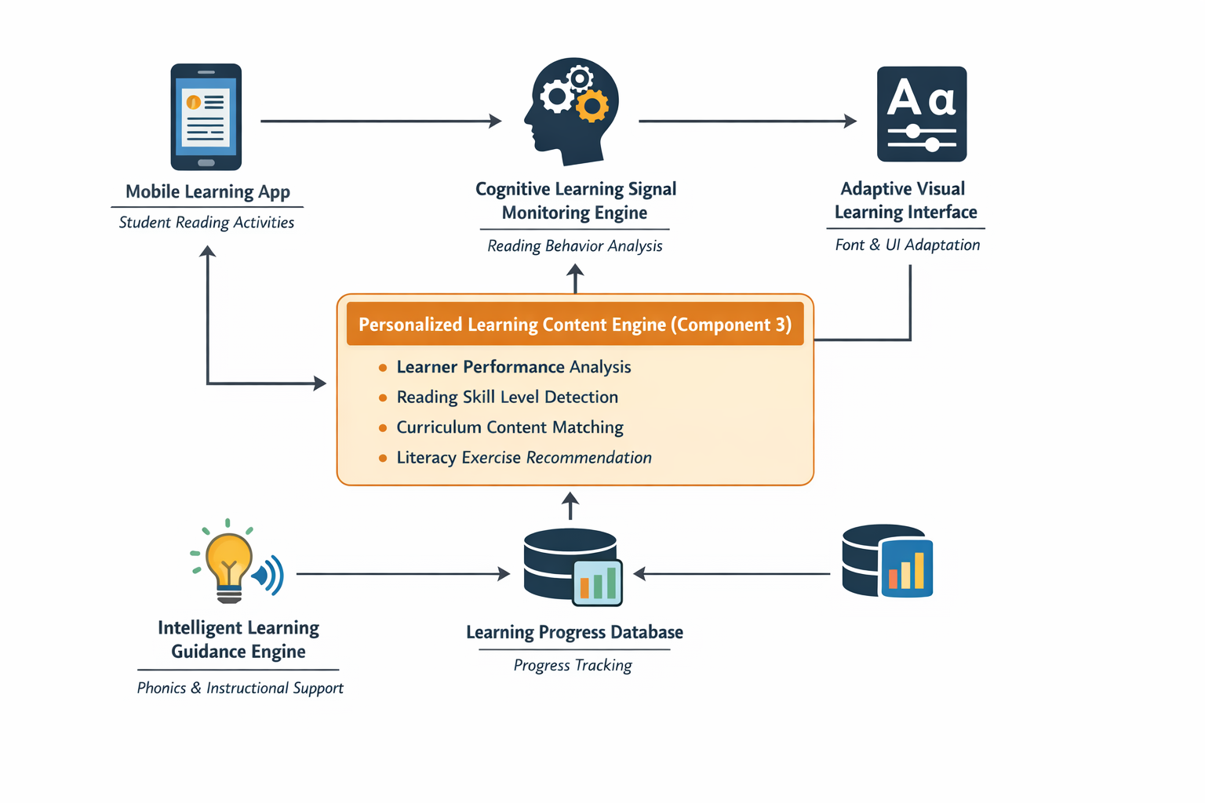
Figure 1 - High Level System Architecture

The system diagram presents the overall architecture of the adaptive learning platform and the relationships between its main components.
Students interact with the Mobile Learning Application, where reading and literacy activities are performed. The interaction data generated from these activities are analyzed by the Cognitive Learning Signal Monitoring Engine to identify learner performance patterns.
Based on the analyzed learning signals, the Personalized Learning Content Engine selects suitable learning materials according to the learner’s reading ability. The selected content is then processed by the Adaptive Visual Learning Interface, which regenerates the content in a dyslexia-friendly format.
The Intelligent Learning Guidance and Intervention Engine further supports the learning process by recommending appropriate learning strategies and instructional interventions.

Highlight the Individual Component and Its Parts
The Personalized Learning Content Engine is responsible for identifying appropriate learning materials based on learner performance and reading ability. It analyzes learning progress and selects suitable educational content that supports the learner’s reading development.
This component consists of several internal functional parts:
Learner Performance Analysis
Processes learner activity data such as reading accuracy, activity scores, and completion time to evaluate learner progress.
Reading Skill Level Detection
Determines the learner’s reading proficiency level based on analyzed performance indicators.
Learning Content Repository
Stores curriculum-aligned reading passages, literacy exercises, and phonics-based learning materials used by the system.
Content Matching and Selection Module
Matches learner skill levels with suitable learning materials stored in the repository and selects appropriate literacy exercises for the learner.
Content Output Module
Transfers the selected learning content to the visual adaptation component so that it can be presented in a dyslexia-friendly format.

Component Interactions
The system components interact through a continuous adaptive learning process. Students perform reading and literacy activities through the mobile learning application, which generates interaction data during each learning session.
These interaction signals are analyzed by the Cognitive Learning Signal Monitoring Engine, which identifies learner performance indicators and reading difficulty patterns. The analyzed learning information is then used by the Personalized Learning Content Engine to determine suitable learning materials for the learner.
The selected learning content is passed to the Adaptive Visual Learning Interface, where the learning materials are visually adapted to improve readability for dyslexic learners. In parallel, the Intelligent Learning Guidance and Intervention Engine recommends appropriate instructional strategies and supportive activities to strengthen reading skills.
Through these interactions, the system continuously adapts learning content, presentation style, and instructional support according to the learner’s progress.

Data Flow Explanation
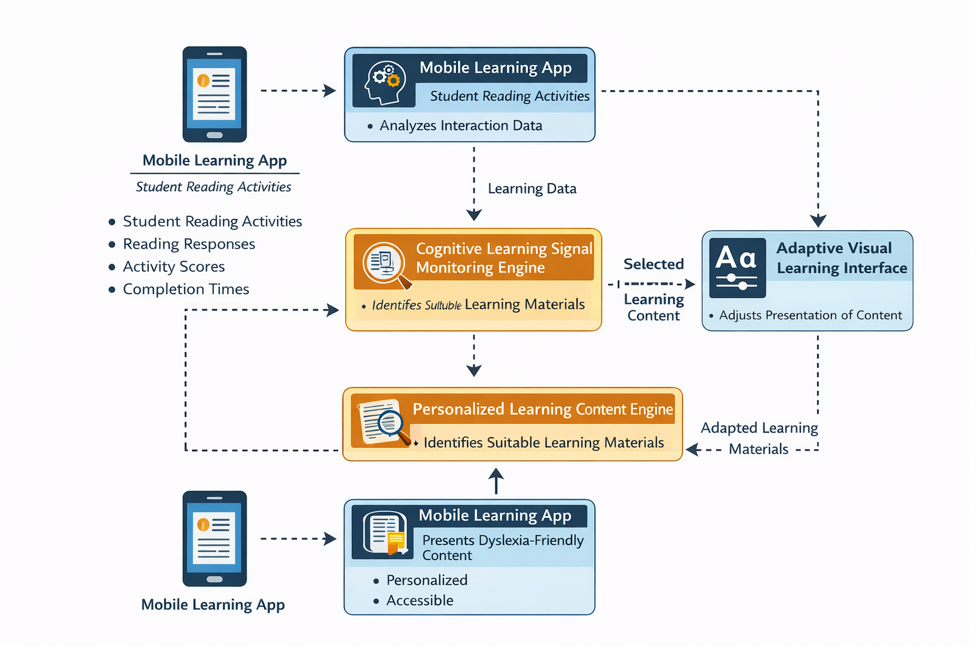
Figure 2 - Data Flow Explanation
The data flow begins when students perform reading and literacy activities using the mobile learning application. During these activities, interaction data such as reading responses, activity scores, and completion times are collected.
This data is sent to the Cognitive Learning Signal Monitoring Engine, where learner performance indicators are extracted. The analyzed learning signals are then forwarded to the Personalized Learning Content Engine, which identifies suitable learning materials based on the learner’s reading ability and progress.
The selected learning content is passed to the Adaptive Visual Learning Interface, where the system regenerates the content by adjusting typographic and visual elements to create a dyslexia-friendly reading environment.
Finally, the adapted learning materials are presented to the learner through the mobile application interface, allowing students to continue their learning activities in a personalized and accessible format.

Scalability and Security Considerations
The proposed system is designed to support scalability by allowing the platform to expand its learning resources and language support without major architectural changes. The system architecture enables the integration of additional learning content and supports multiple languages such as Tamil and English, allowing the platform to accommodate learners from different linguistic backgrounds.
Security and privacy are also important considerations in the system design. Student learning data collected through the application are securely stored and protected using authentication mechanisms and encrypted communication. Personal information is anonymized to ensure learner privacy and to maintain ethical data management practices in educational environments.

USER REQUIREMENTS

Stakeholder Identification
The proposed adaptive learning system involves several stakeholders who interact with or benefit from the platform.
Students (Primary Users)
Primary school students with dyslexia are the main users of the system. They use the mobile application to perform reading activities, literacy exercises, and interactive learning tasks designed to improve reading fluency and comprehension.
Teachers
Teachers can use the system to monitor student learning progress and identify reading difficulties. The platform helps teachers understand student performance and provide additional educational support when necessary.
Parents or Guardians
Parents can support children’s learning activities by encouraging them to use the application regularly and observing their learning progress outside the classroom environment.
Researchers and System Developers
Researchers and developers are responsible for designing, maintaining, and improving the system. They analyze system data and user feedback to enhance learning models and system functionality.

Functional Requirements
The system should provide the following core functionalities:
FR1 – User Registration and Login
The system shall allow users to create accounts and securely log into the mobile learning application.
FR2 – Student Reading Activities
The system shall provide interactive reading exercises, literacy tasks, and comprehension activities through the mobile application.
FR3 – Learning Interaction Monitoring
The system shall collect and analyze student interaction data such as reading responses, task completion time, and activity scores.
FR4 – Personalized Learning Content Selection
The system shall analyze learner performance and select appropriate learning materials that match the learner’s reading ability.
FR5 – Adaptive Visual Content Presentation
The system shall adjust visual presentation elements such as font size, spacing, and layout to create a dyslexia-friendly reading environment.
FR6 – Instructional Guidance and Learning Support
The system shall recommend suitable learning interventions such as phonics exercises, audio-assisted reading, and multisensory learning activities.
FR7 – Learning Progress Tracking
The system shall track student performance and maintain learning progress records over time.
FR8 – Multilingual Learning Support
The system shall support multiple languages such as Tamil and English to accommodate learners from different linguistic backgrounds.

Non-Functional Requirements
Non-functional requirements define the quality attributes and operational constraints of the system.
Security
The system must protect student data through secure authentication mechanisms and encrypted data storage to ensure privacy and confidentiality.
Performance
The system should process learning data and generate personalized learning recommendations with minimal delay to maintain smooth user interaction.
Usability
The mobile application should provide a simple, intuitive, and child-friendly interface suitable for young learners with reading difficulties.
Accessibility
The system should support dyslexia-friendly design principles such as readable fonts, adjustable text spacing, and clear visual layouts.
Scalability
The system should be capable of supporting increasing numbers of users and expanding learning resources without significant performance degradation.
Reliability
The system should operate consistently with minimal system failures to ensure uninterrupted learning activities.

COMMERCIALIZATION PLAN

Target Market and Customer Persona
The primary target market for the proposed system includes primary schools, special education centers, and parents of children with dyslexia in Sri Lanka. Many schools and parents seek accessible digital learning tools that support children experiencing reading difficulties.
The system is particularly designed for primary school students aged 6–12 years who require additional reading support. Educational institutions can use the platform as a supplementary learning tool to help students improve reading fluency and comprehension.
A typical customer persona includes primary school teachers, special education instructors, and parents who are looking for an effective digital platform that provides personalized literacy exercises and structured reading support for children with dyslexia.

Value Proposition
The proposed system provides a personalized mobile learning environment specifically designed for students with dyslexia. The platform combines adaptive learning techniques, personalized content selection, and dyslexia-friendly visual presentation to improve reading accessibility and engagement.
By analyzing learner interaction data, the system continuously adapts reading materials and learning activities according to the learner’s performance and reading ability. This approach allows students to practice reading at an appropriate difficulty level while gradually improving literacy skills.

Revenue Model
The system can adopt a subscription-based revenue model where schools or parents subscribe to the platform to access personalized learning features.
Possible revenue streams include:
- Individual user subscriptions for parents who want to support their children’s reading development at home.
- School licensing packages that allow multiple students to access the system within an educational institution.
- Premium educational content packages that provide additional literacy exercises and learning activities.
This model allows the platform to generate sustainable revenue while maintaining accessibility for educational users.

Cost Estimation
The main costs involved in developing and maintaining the system include:
System Development Costs
Costs related to mobile application development, system design, and implementation of adaptive learning functionalities.
Educational Content Development
Creation of Sinhala reading materials, literacy exercises, and curriculum-aligned educational content.
Cloud Infrastructure Costs
Expenses related to database storage, server hosting, and cloud services used to store learning data and system resources.
Maintenance and Updates
Ongoing system improvements, bug fixes, and updates required to maintain system performance and reliability.

Pricing Strategy
The pricing strategy is designed to ensure affordability for Sri Lankan schools and families.
Possible pricing plans include:
Plan Type | Target Users | Price Range | Features
Individual Student Plan | Individual students / parents | LKR 500 – LKR 700 per month | Access to personalized learning features and reading exercises
School Plan | Schools and educational institutions | LKR 25,000 – LKR 40,000 per year | Institutional access for multiple students and teachers
Free Basic Version | General users | Free | Limited reading exercises with basic learning features
Table 2 - Pricing Strategy

Competitive Advantage
The proposed system offers several advantages compared to general digital learning applications:
- Focused support for dyslexic learners rather than general learning platforms.
- Personalized learning content selection based on learner performance.
- Adaptive visual reading interface designed to improve readability for students with dyslexia.
- Mobile-based learning accessibility, allowing students to practice reading anytime and anywhere.
- Content designed specifically for the Sri Lankan primary education context.
These features enable the platform to provide more targeted and effective reading support for students with dyslexia.

Intellectual Property Considerations
The proposed system includes several intellectual property elements that should be protected to support future commercialization.
Software Copyright
The mobile application, system architecture, and implemented algorithms will be protected under software copyright laws.
Educational Content Protection
All literacy exercises, reading passages, and learning materials developed for the system will be protected through copyright.
System Design and Algorithms
The adaptive learning mechanisms and content selection methods may be considered for intellectual property protection to prevent unauthorized use or duplication.
Proper intellectual property protection will help secure the innovation and support long-term commercialization opportunities.

BUDGET AND JUSTIFICATION
No. | Budget Item | Unit Cost (LKR) | Qty | Total (LKR) | Justification
Software Licenses
1 | Python 3.10 + scikit-learn + FastAPI + Redis | Free | — | — | All open-source zero cost. Core ML and API stack for Components 1, 3, and 4 classifiers, REST endpoints, and WebSocket server.
2 | React + Tailwind CSS + Recharts + HTML5 Canvas API | Free | — | — | Open-source front-end stack for Component 2 adaptive UI and Component 4 intervention activities. No licensing fee.
3 | GTTS (Google Text-to-Speech) | Free | — | — | Free Python library. Supports Sinhala (si) and Tamil (ta) locales. Used in Component 4 for syllable audio and Template Song generation. Offline after first run.
4 | PostgreSQL — learner model and content database | Free | — | — | Open-source relational database. Stores BKT mastery, SM-2 schedules, intervention history, RSI logs, and content metadata across all components.
5 | GitHub Education Pack — version control and CI/CD | Free | — | — | Free for SLIIT students. Covers all four component repositories, Actions CI/CD pipelines, and private team collaboration.
6 | Figma — UI wireframes and usability prototypes | Free | — | — | Free student tier. Used for Component 2 visual template design and caregiver/teacher usability testing prototypes.
Cloud Services
7 | Oracle Cloud Free Tier — app hosting and PostgreSQL | Free | — | — | Always-Free tier provides 2 AMD VMs and 20 GB storage — sufficient for all four component microservices at research and pilot scale.
8 | Redis Cloud Free Tier — RSI event pub-sub streaming | Free | — | — | 30 MB free Redis instance sufficient for real-time RSI streaming between Component 1 and Components 2, 3, and 4 during pilot sessions.
9 | Internet charges — development and pilot study (6 months) | 400 | 6 | 2,400 | LKR 400/month Sri Lanka mobile data plan (~15 GB/month). Covers model downloads, package installs, gTTS API calls, and optional dashboard synchronisation.
Human Effort Costs
10 | Inclusive education specialist — exercise bank review | 3,000 | 1 | 3,000 | One-time review of Component 3 phonological drill bank and Component 4 multisensory activity design for clinical appropriateness and alignment with DSM-5 and ICD-11 dyslexia intervention principles.
11 | Song and poem authoring or copyright clearance | 2,000 | 1 | 2,000 | Commission culturally appropriate Sinhala and Tamil songs and rhymes for Component 4 Template Song activity, or obtain rights clearance. Content mapped to NIE phonological targets for Grade 1 and Grade 2.
12 | NIE curriculum material sourcing and digitization | 2,000 | 1 | 2,000 | Legal procurement, scanning, and digitization of Grade 1–3 Sinhala and Tamil NIE curriculum materials for Component 3 content mapping ontology and Component 4 word difficulty dataset construction.
13 | Ethics consent form printing (English, Sinhala, Tamil) | 30 | 160 | 4,800 | 160 pages: consent and participant information sheets for 20 pilot families across three languages, plus school administrator copies. LKR 30 per page standard Sri Lankan print-shop rate.
14 | Travel to partner schools — all field visits | 950 | 20 | 19,000 | LKR 950 per return visit (bus or tuk-tuk). Component 1 data collection: 6 visits. Component 2 usability testing: 4 visits. Component 4 pilot study, ethics submission, and close-out: 10 visits. Total: 20 visits across the project.
15 | Participant refreshments — pilot study sessions | 250 | 20 | 5,000 | LKR 250 per child per session for snacks and drinks. Ethical best practice for research involving children; builds rapport and reduces attrition across Component 1 and Component 4 sessions.
16 | Stationery, printed forms and field notebooks | 2,500 | 1 | 2,500 | Session observation checklists, researcher field notes, and annotation worksheets used across all four components during data collection and the pilot study.
17 | Contingency reserve (10% of direct cash costs) | — | — | 5,670 | Reserve for unexpected travel, reprinting, additional reviewer sessions, or minor unforeseen needs. Applied only to direct cash outgoings — not to zero-cost tools or free hosting services.
TOTAL ESTIMATED BUDGET (LKR) |  |  |  |  | 62,370
Table 3 - Budget and justification

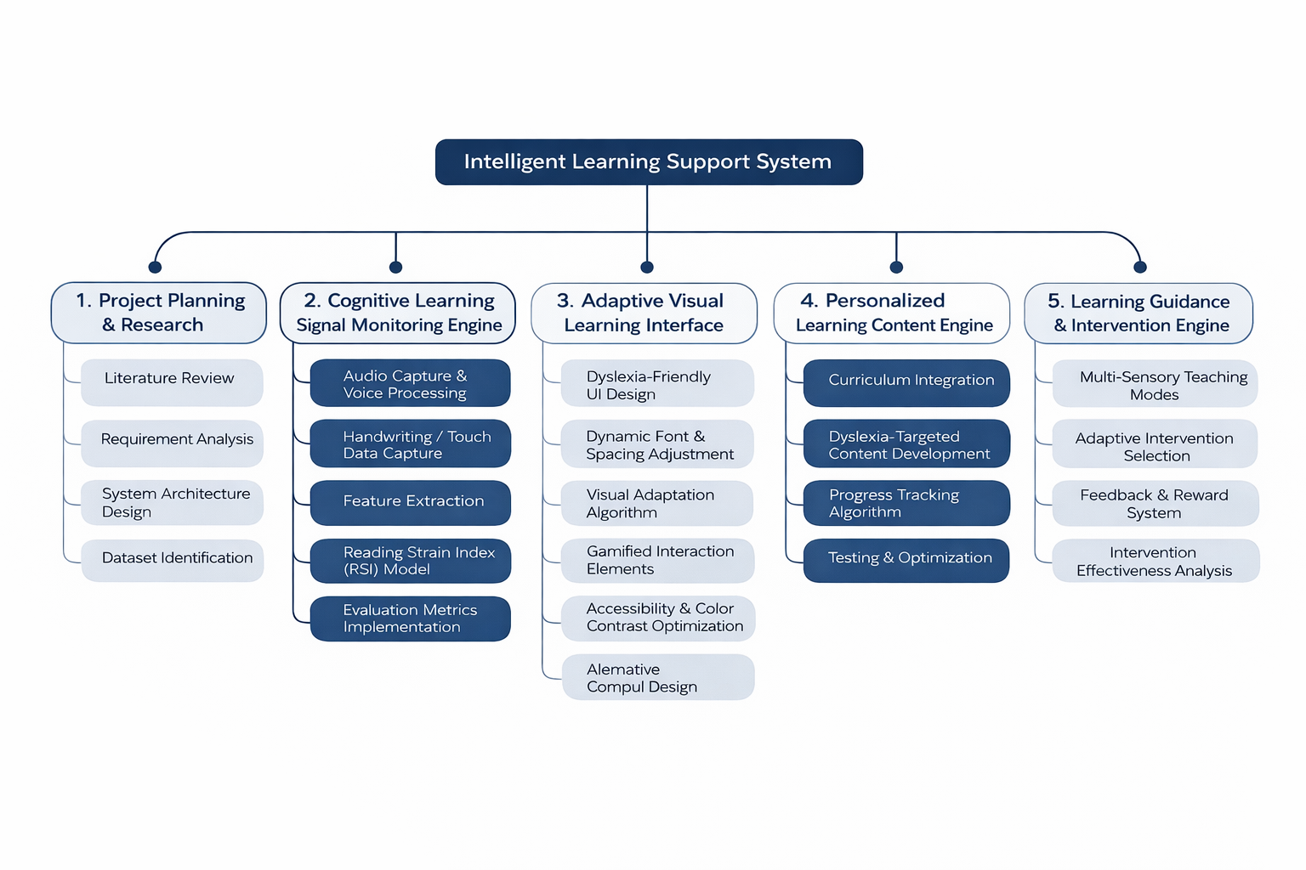
WORK BREAKDOWN STRUCTURE(WBS)
Figure 3 - Work breakdown structure

GANTT CHART

Figure 4- Gantt chart

Phases | March | April |  |  | May |  |  | Jun | Jul | Aug | Sep | Oct | Nov | Dec
Proposal
Design Wireframes & Prototype
Data Collection
Backend Implementation
Data Processing
Model Development
Check List Submission
Progress Presentation 1
Final Check List Submission
Progress Presentation 2
Final Documentation
Website Submission
Final Presentation

REFERENCES LIST

[1] | Katsaris, I. , N. Vidakis, "Adaptive e-learning systems through learning styles: A review of the literature," syncsci, 2021.
[2] | Dr. Kiran P, Venumadhava H, G Pranathi, Navya D N, "AI-Powered Assistive Technologies for Dyslexia: A Survey on Advancing Learning and Accessibility," IJARCCE, 2024.
[3] | M. Z. J. C. Z. Conrad Perry, "Understanding Dyslexia Through Personalized Large-Scale Computational Models," Sage Journals Home, 2019.
[4] | R. H. Weam Gaoud Alghabban, "Exploring the Effectiveness of Adaptation Based on Dyslexia Type and Reading Skill Level to Support Learners with Dyslexia," scienceopen, 2022.
[5] | K. H. A. Aisha Y. Alsobhi, "Learning Styles and Dyslexia Types – Understanding Their Relationship and its Benefits in Adaptive E-learning Systems," i-jim, 2020.
[6] | J. M. A. L. A. Z. E. Y. B. J. T. G. C. Gianluca Morciano, "AI-based Recommendation System to Suggest Learning Tools and Strategies for Dyslexic Students," arXiv, 2024.
[7] | I. R.-R. D. C.-B. A. O. A. S. J. L. L. J. Ignacio Mateo Trujillo, "Optimizing dyslexia intervention through an adaptive sequential recommender system," sciencedirect, 2025.
[8] | T. I. Miroslav Popov, "Knowledge Model for Developing, Searching and Using Personalized Learning Content for Learners Having Dyslexia Disability," dl.acm, 2020.
[9] | N. K. H. R. Aisha Yaquob Alsobhi, "Personalised Learning Materials Based on Dyslexia Types: Ontological Approach," sciencedirect, 2015.
[10] | R. H. Weam Gaoud Alghabban, "Adaptive E-Learning and Dyslexia: An Empirical Evaluation and Recommendations for Future Work," Oxford Academic, 2023.
[11] | V. V. P. D. G. B. D. M. K. M. Maragadhavalli Meenakshi, "Leveraging AI Technologies for Personalized Learning Support in Dyslexic Students," IJRASET, 2024.
[12] | V. T. P. K. Rumen Andreev, "An Approach to Development of Personalized E-learning Environment for Dyslexic Pupils’ Acquisition of Reading Competence," dl.acm, 2009.

APPENDICIES

Appendices A
Risk Analysis –
This appendix identifies potential risks that may arise during system development and implementation.
Risk | Description | Mitigation Strategy
Data privacy concerns | Student learning data must be protected | Implement secure cloud storage and access control
Limited training data | AI models require sufficient learning data | Use incremental data collection and model improvement
User adoption challenges | Teachers and students may resist new technology | Provide training and simple user interface
Technical performance issues | Mobile app performance on low-end devices | Optimize application performance
Table 4 - Risk Analysis

Appendices B
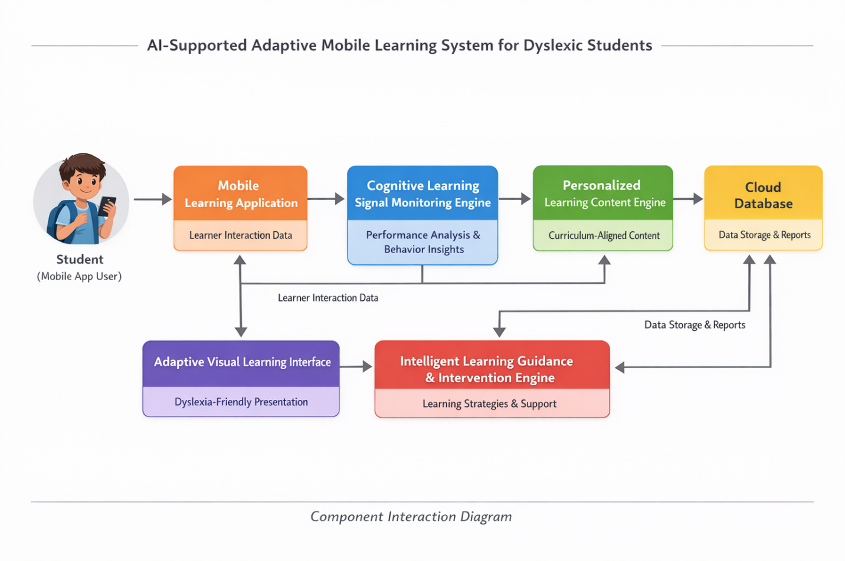
Component Interaction Diagram
Figure 5 - Component Interaction Diagram

